# Exercise Set#2 - File Handling Commands, control operators & Linux file system structure

**File Handling**

The Objective is to learn basic file handling commands. Explore the commands for the below subtopics.

**Videos :** Linux2-directory_structure, Linux2-find, Linux2-grep

**1. Command helps and Command manuals**

**a. Learn how to get the help for any command using the –h OR --help option (e.g. ls --help).**

**Ans :** 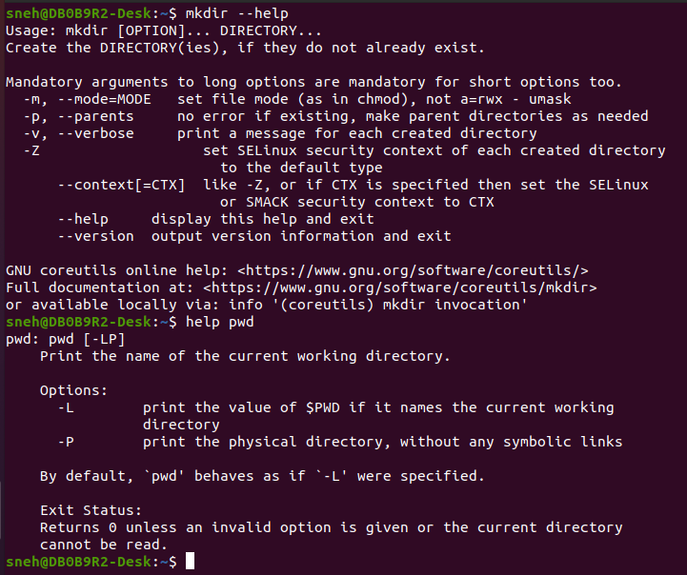

**b. Learn how to use the <man> command i.e. manual for any keyword.**

**Ans :**

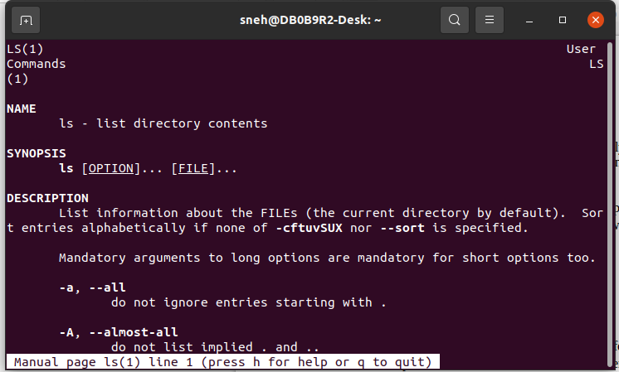

**c. Learn different levels of man command**

**Ans :**

The man command provides access to manual pages organized into different sections.These sections are as follows :

User Commands (Section 1): This section typically contains manual pages for user commands, such as basic utilities and user-level programs.

System Calls (Section 2): Contains documentation for system calls, which are low-level interfaces to the kernel.

Library Functions (Section 3): Documentation for library functions and routines.

Device and Network Interfaces (Section 4): Describes device files, drivers, and network-related information.

File Formats and Conventions (Section 5): Provides information about file formats, configuration files, and conventions.

Games (Section 6): Documentation for games .

Miscellaneous (Section 7): Contains miscellaneous documentation, such as macro packages and conventions.

System Administration Commands (Section 8): Documentation for system administration and maintenance commands.

**d. Apropos**

**Ans :**

Apropos is a command that searches manual pages for a keyword or topic and returns a list of relevant commands. It is used for quickly finding commands you need, especially if you don't remember exact command name.

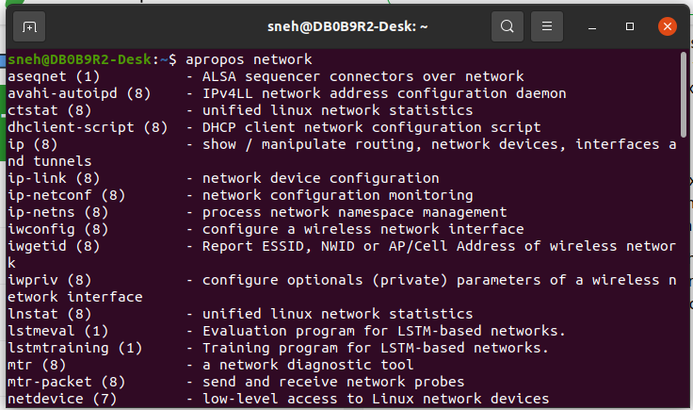

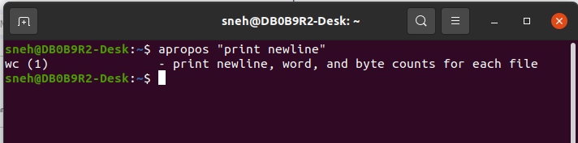

**2. Handling files and directories**

**a. Listing the files <ls> with all the options. Study the details listed by <ls -l>.**

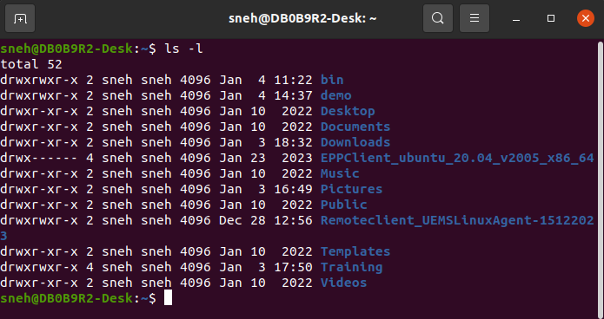

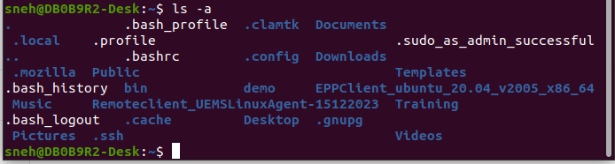

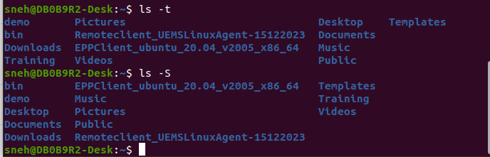

**b. Printing the current working directory <pwd>**



**c. Changing the current directory <cd>**

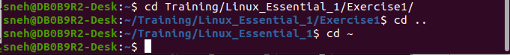

**d. Creating a directory <mkdir>**

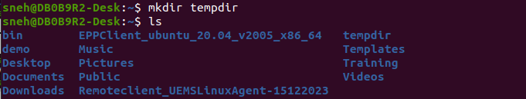

**e. Removing directory <rmdir>**

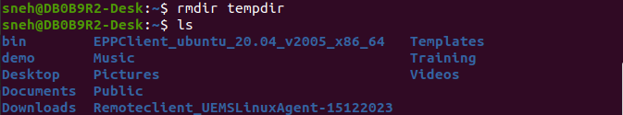

**f. File copy command <cp>**

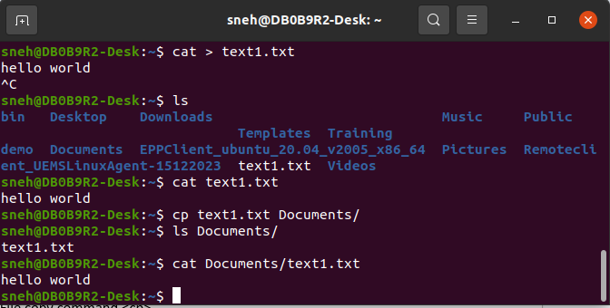

**g. Rename/Moving a file <mv>**

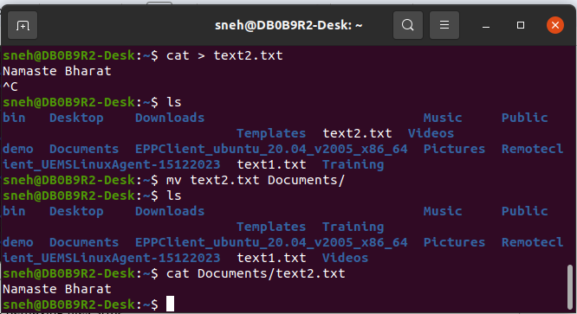

**h. Removing files <rm>**

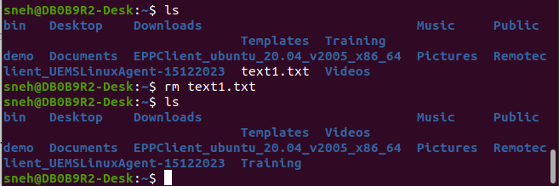

**3. Displaying, Searching, Sorting and comparing files**

**a. Displaying contents of a file <cat>**

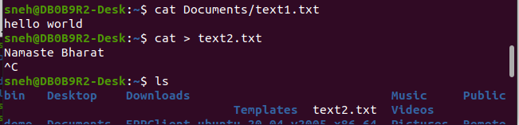

**b. Display the disk usage <du> and disk free <df>**

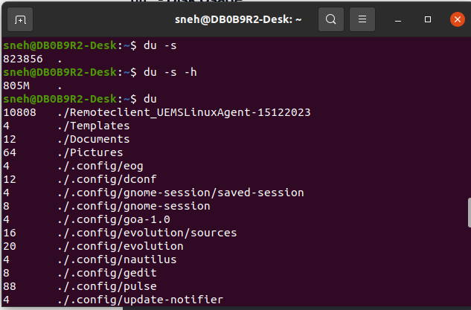

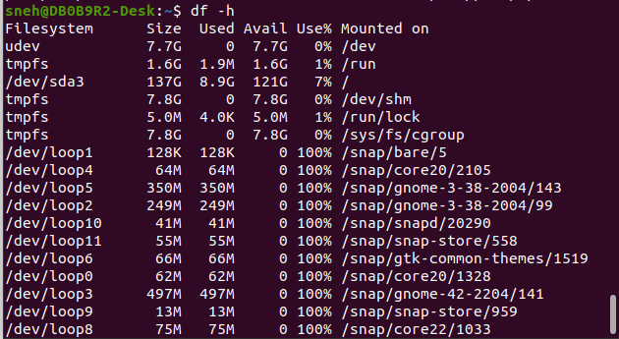

**c. Searching a string in files <grep>**

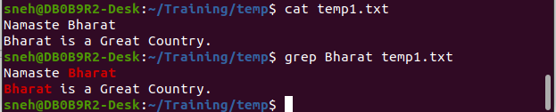

**d. Sort the lines in a file <sort>**

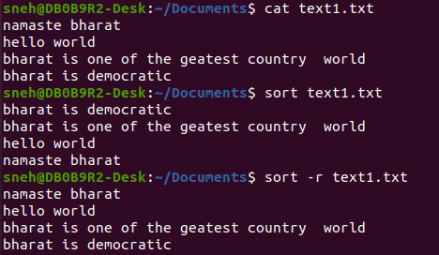

**e. Finding/locating files <find>, <locate>**

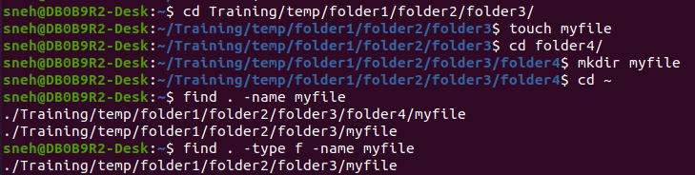

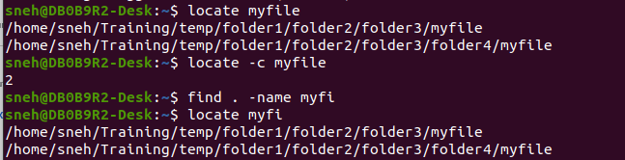

**f. Comparing files/dirs <diff>, <meld>**

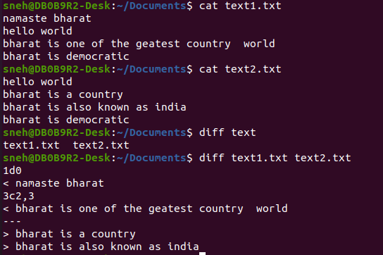

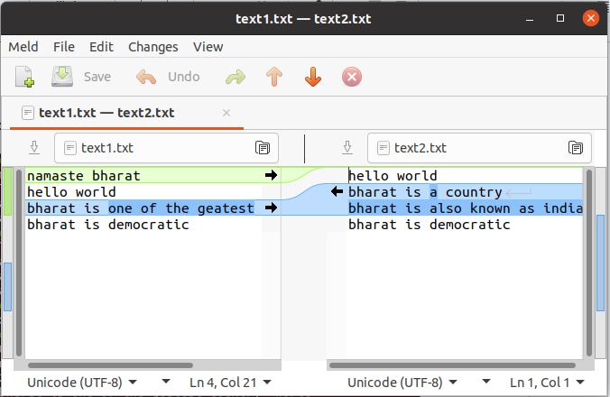

**g. Extracting field/character <cut>**

**Ans :**

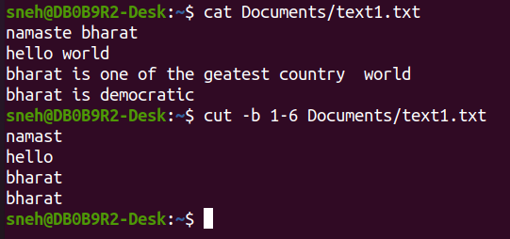

**4. Symbolic and hard links**

**a. Understand how to identify the symbolic links to files/dirs**

**Ans :**

We can use ls -l command in which those file having its type l in permissions first place are symbolic or soft link

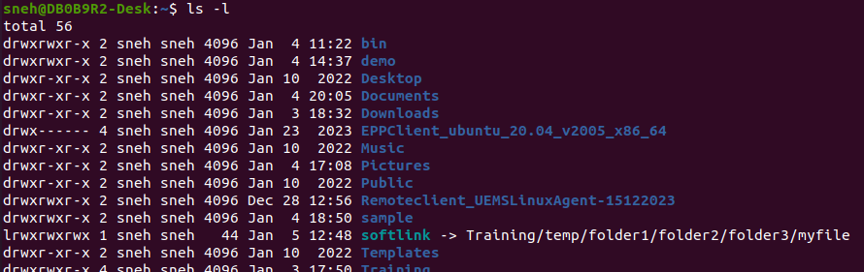

**b. What is a Soft link and Hard link?**

**Ans :**

A soft link is a separate file that contains a reference to the target file or directory. Each hard linked file is assigned they refer the same physical file location.

If we have a file a.txt. If we create a hard link to the file and then delete the file, we can still access the file using hard link. But if we create a soft link of the file and then delete the file, we can’t access the file through soft link and soft link becomes dangling.

**c. Creating symbolic link <ln>**

**Ans :**

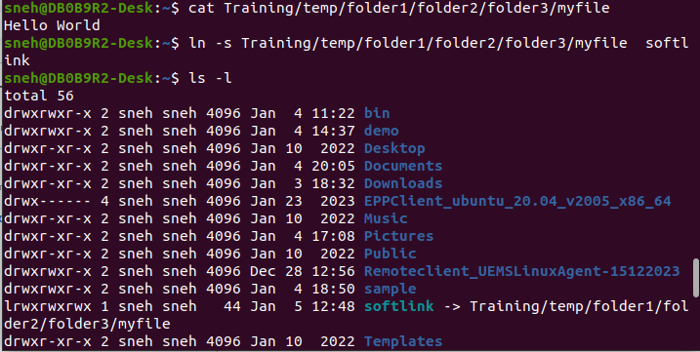

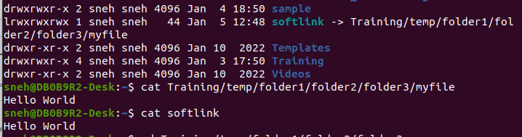

**d. Removing a link <rm>**

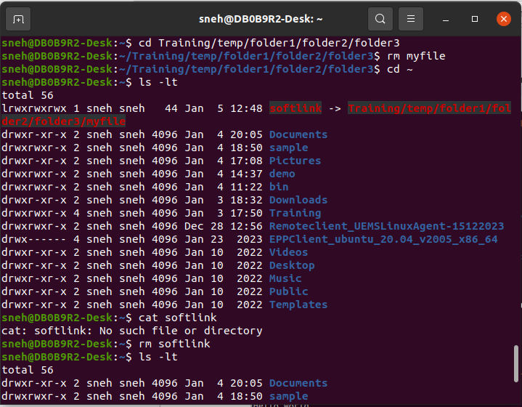

**5. File Access Rights**

**a. Using the <ls –l> command display the details of a particular directory/file**

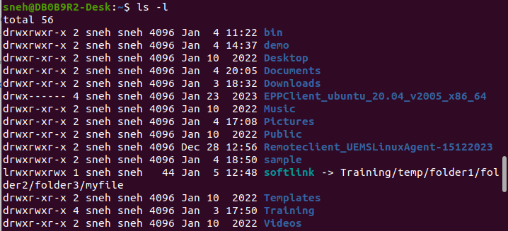

**b. Understand the various details displayed for the files/dir i.e. the access rights, access levels, group the file belongs to, owner of the file etc**

**Ans :**

The first character in first column represents the file type, for eg. directory, softlink.

The next three characters represent the owner's permissions.

The next three characters represent the group's permissions.

The last three characters represent others permissions.

The second column indicates the number of hard links associated with the file or directory.

The third column indicates the owner of the file or directory.

The fourth column indicates the group associated with the file or directory.

The fifth column shows the size of the file in bytes.

The next columns indicate the date and time when the file or directory was last modified.

The last column displays the name of the file or directory.

**c. Create a new directory and a file in that directory and change the permissions of the file using the <chmod> command.**

**Ans :**

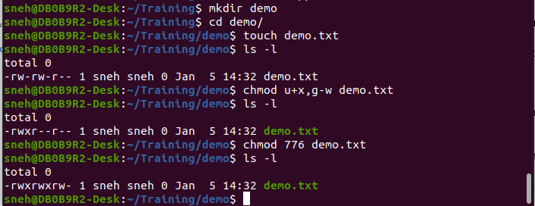

**6. File Compression and Archiving**

**a. Compressing files or directories <gzip>, <bzip2>**

**Ans :**

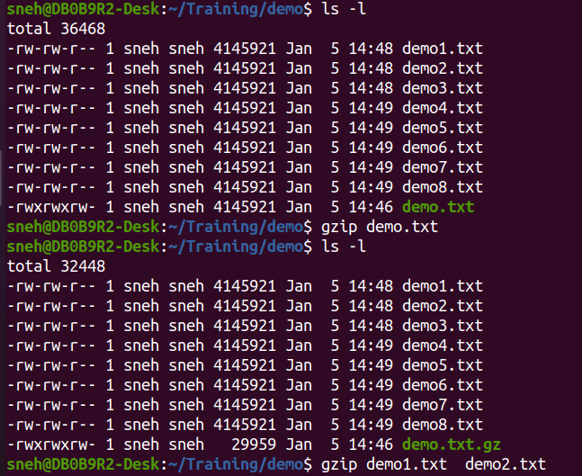

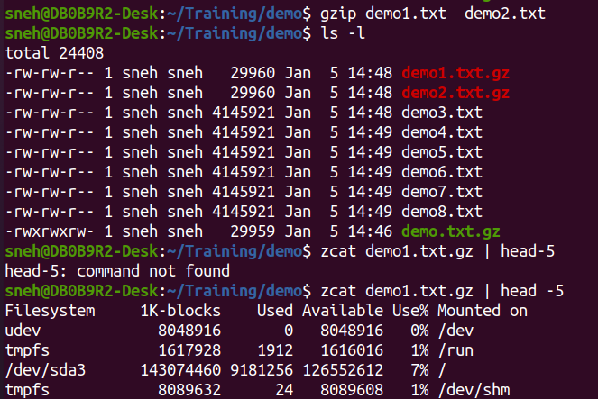

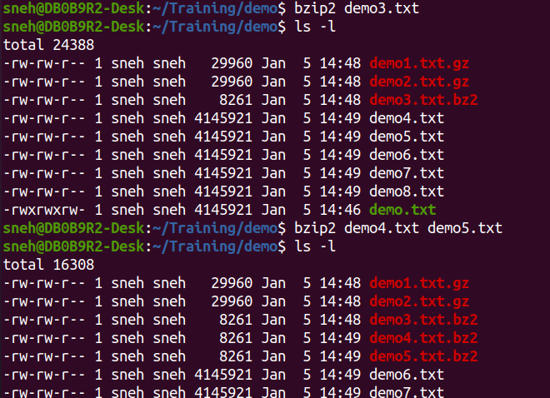

**b. Uncompress a file <gunzip>, <bunzip2>**

**Ans :**

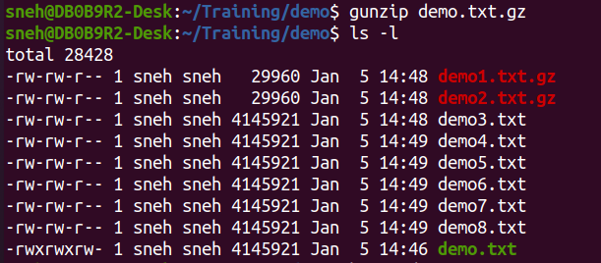

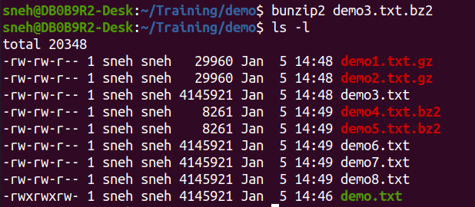

**c. Creating a compressed archive <tar>**

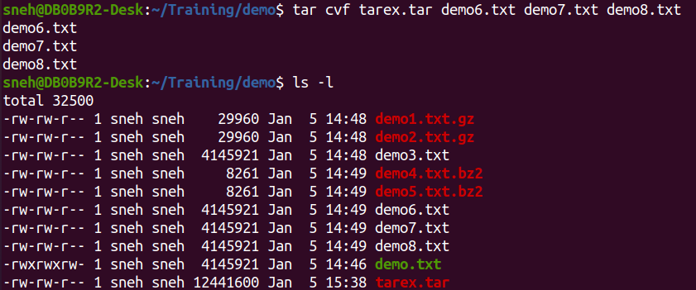

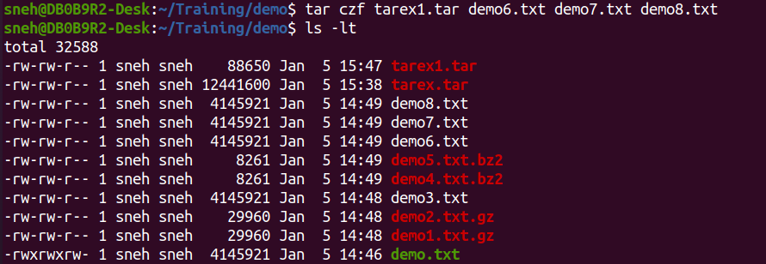

**d. Extracting the contents of compressed archive <tar>**

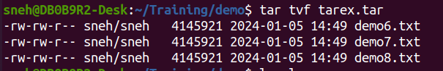

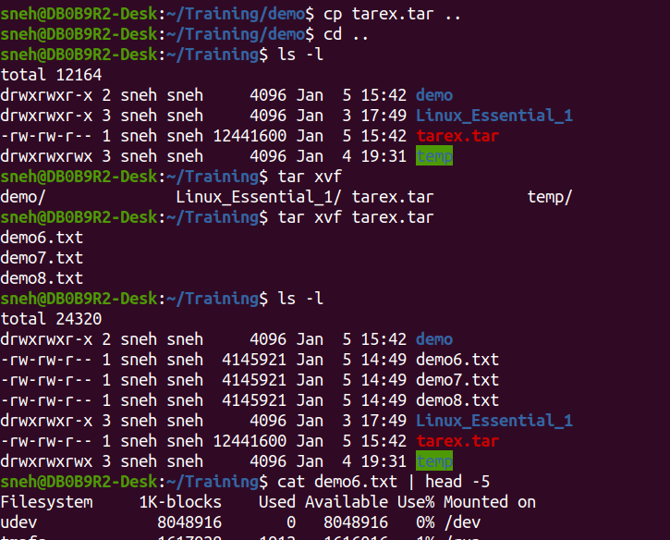

**e. Creating zip archives <zip>**

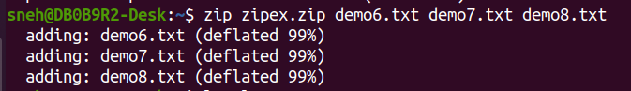

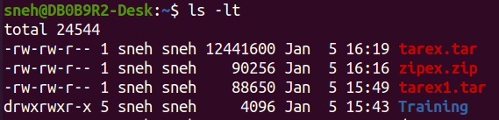

**f. Extracting zip archives <unzip>**

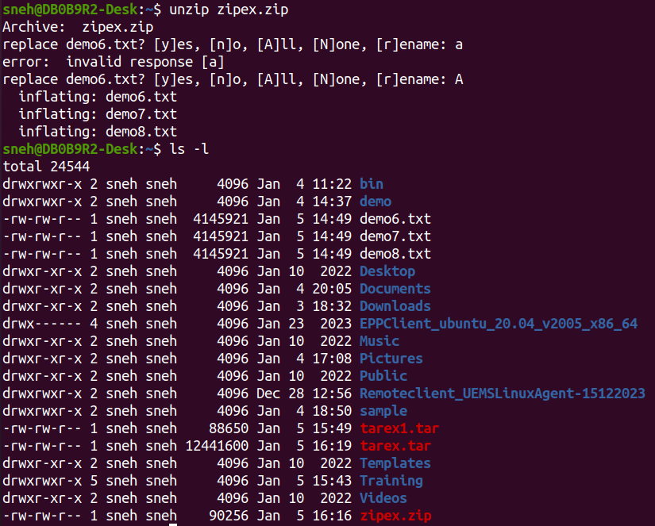

**7. Linux file system structure**

**a. Read about the basic Linux file structure.**

**Ans :**

Linux file system is used in linux operating system to organize and store file and data in computer. It is a hierarchical, tree-like structure that starts with the root directory, which contains all other directories and files

**b. Understand the root </> directory structure and the requirement of the subdirectory within the root directory i.e. /dev, /mnt, /tmp etc.**

**Ans :**

/ (Root directory): The top-level directory in the Linux file system hierarchy.

/bin (Binary): Contains essential binary executable files (programs).

/boot: Contains the files necessary for booting the system.

/dev (Devices): Contains device files, which represent and allow interaction with hardware devices.

/etc: Contains Configuration files.

/home: Contains user home directories, where users store their personal files.

/lib (Library): Contains shared library files needed for the system.

/mnt (Mount): Historically used as a temporary mount point for file systems.

/root: Home directory for the root user(Admin).

/tmp (Temporary): Used for temporary files that are deleted upon reboot.

�